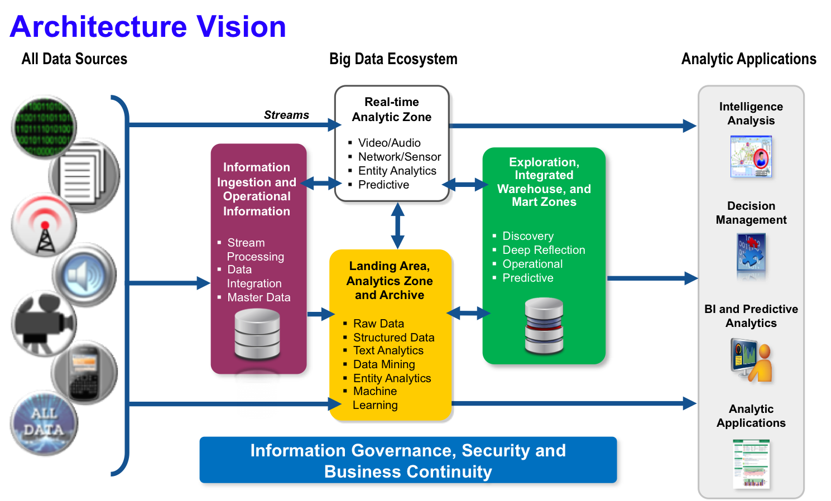

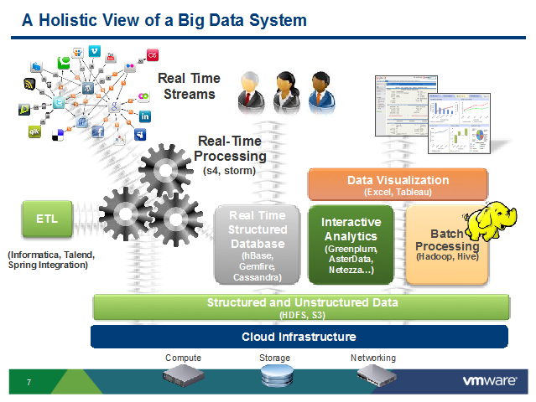

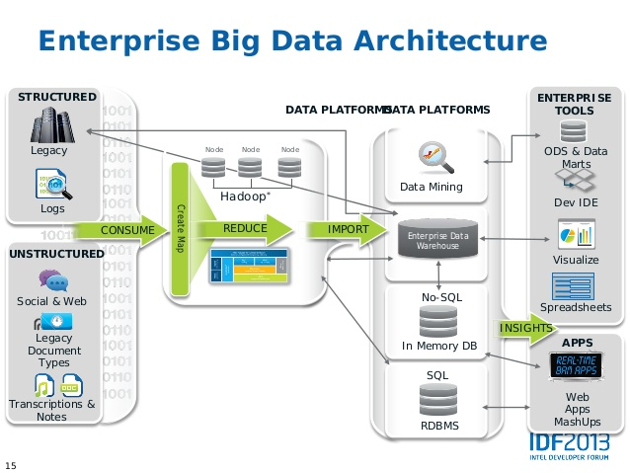

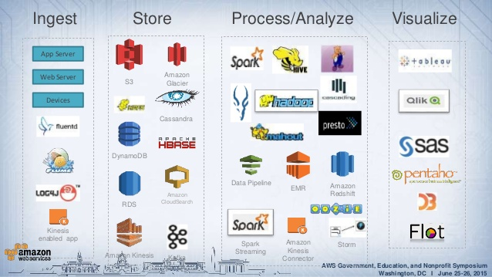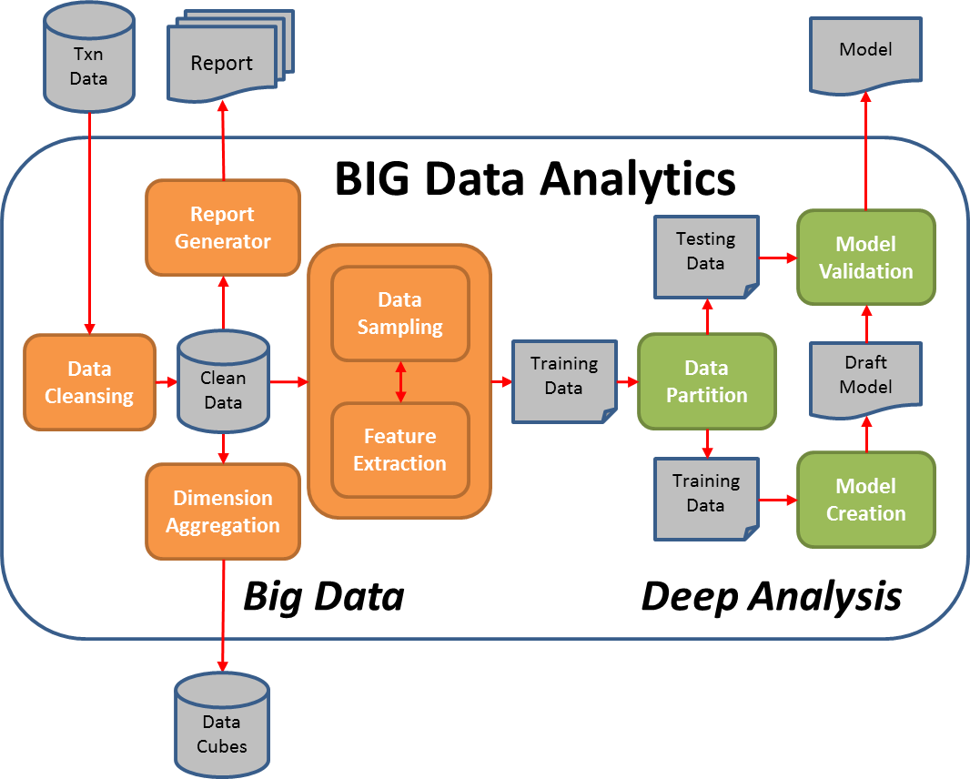

**Attributes of Highly Effective Big Data Environments**

* Seamlessly Use Data Sets: Much of the payoff comes through the mixing, combining and contrasting of data sets – so there’s no analytics-enabled innovation without integration
* Flexible, Low Cost: The target here is low complexity and low cost, with sufficient flexibility to scale for future needs, which will be both larger-scale and more targeted at specific user groups
* Stable: Stability is critical because the data volumes are massive and users need to easily access and interact with data. In this sense, infrastructure performance holds a key to boosting business performance through big data

